**FULLSTACK DEVELOPMENT PROGRAM**

**TRAINING REPORTS**

**Submitted in partial fulfilment of the requirements for the award of degree of**

**Bachelor of Technology in Computer Science & Information Technology**



**Session: 2020-2021**

**Rajasthan Technical University, Kota (Raj.)**

**Submitted By:-**

Swastik Shresth (18EARIT061)

Jahanvi Goyal (18EARCS058)

Pramit Vishwakarma (18EARIT043)

**Under the Supervision of Mentor:-**

**Mr. Sanjay Rathore**

**Mr. Ankush Sharma**

**DEPARTMENT OF COMPUTER SCIENCE & INFORMATION TECHNOLOGY**

**ARYA COLLEGE OF ENGINEERING & INFORMATION TECHNOLOGY**

**SP-42, RIICO INDUSTRIAL AREA ,KUKAS, JAIPUR-302028**

**FULLSTACK DEVELOPMENT TRAINING REPORT (2020-21)**

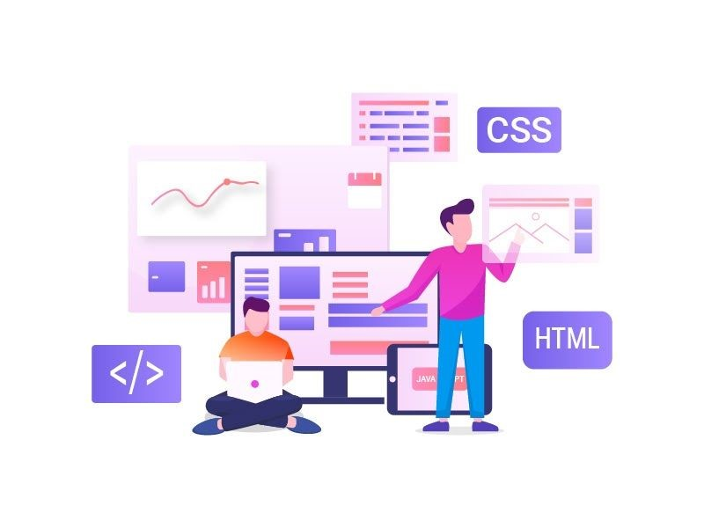

### ​ABSTRACT

* The project report has been prepared based on available data, forecasts provided by experts and other project management tools.
* This project is considered as a non profit project. Risks have been estimated based on these types of projects.
* Full efforts have been made to complete this project with proper analysis of its pros and cons.
* The various technologies used in this project are HTML, CSS, node js, JavaScript, angular js, express, mongo DB.
* The whole project is designed using a visual code studio. However, this report is not full proof. There is always a room for improvement.

### INTRODUCTION

* As Technology Advances the internet is becoming ever popular.
* Website has become an essential part .In this project we will develop a website for people to know and analyzed about Day Chef.
* In this report every detail that is necessary has been discussed.
* Day Chef is a platform to make our urban lives more fulfilling to solve our needs in a day.
* It enables users to find services like chefs and housekeeping. They want to be the go-to-platform helping customers complete the projects that are important to their lives.
* Day Chef works on standardized, blue collared services, where you just want the job done, you can directly book and pay for the service.
* The most important factor of marketing technique for companies like Day Chef is Word Of Mouth. So the most part of promotion involves people talking about it. Other than that we use social media for the promotion by the mode of advertisement.
* Target market is divided into different segments say students, working people for example, For most of the students group there used to be a link in the top right corner of their Facebook screens with cooked food images saying ‘Missing Home Cooked Food’ which created a curiosity among the people living away from their houses and the fuss having been created they acquired a large share of market in most of the student areas!

**INSIDE WEB PAGE**

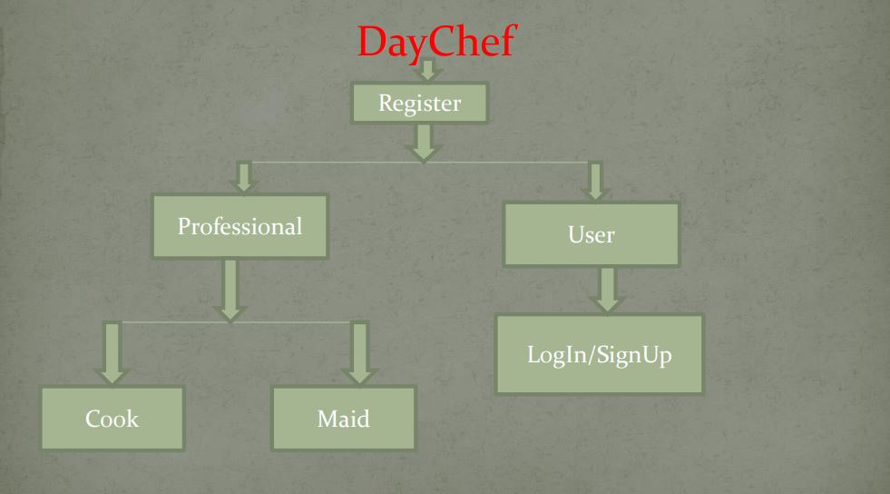

**HOW EXACTLY IT WORKS**

1. First step is kept simple and precise for the customers to understand their services and facilities and how they are to be accessed.
2. If you want to provide your service as a chef then click on ‘Register As a Professional’.
3. If you are a customer, then click on ‘Login/Sign-up’.
4. After logging in, filter the choices and narrow it down, picked up and keep in mind the importance of transparency and the level of the transparency that you are looking for.
5. After choosing the desired option, fill respective form.
6. After being assured and satisfied ‘Confirm Booking’

**BENEFITS**

* Trusted Professionals
* Guaranteed Service
* Ideal for last moment requirements
* Direct interaction between the professionals and customers
* Wide range of choices
* No spam
* Budget fits the choices

### TECHNOLOGIES USED

This project is a full stack project and consists of the following technologies:

Front End:

❖HTML 5 ❖CSS 3 ❖BOOTSTRAP 4 ❖JAVASCRIPT

❖ANGULAR ❖JQUERY ❖NODE.Js

Back End:

❖ JAVASCRIPT ❖TYPESCRIPT ❖ JQUERY

❖ EXPRESS.Js ❖MONGODB ❖NODE.Js ❖API

### PROJECT PROFILE OF CANDIDATES

|  |  |
| --- | --- |
| **CANDIDATES** | **WORK** |
| SWASTIK SHRESTH (Leader) | FULL STACK DEVELOPMENT & MANAGEMENT |
| JAHANVI GOYAL | BACKEND & FRONTEND DEVELOPMENT |
| PRAMIT VISHWAKARMA | FRONTEND DEVELOPMENT & MANAGEMENT |

